

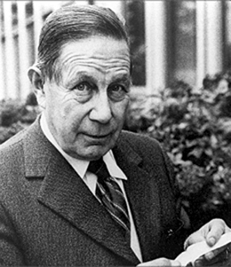
Where did George de Mestral live? |  | _
A | United States
B | Switzerland
C | United Kingdom
D | France

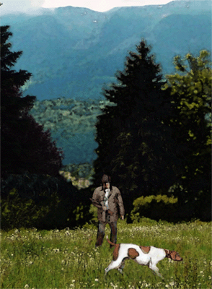
What had George been doing when he found burrs stuck to his clothes and his dog? |  | _
A | He had been walking his dog in a park.
B | He had been playing catch with his dog in a field.
C | He had been training his dog to herd sheep.
D | He had been hunting in the woods with his dog.

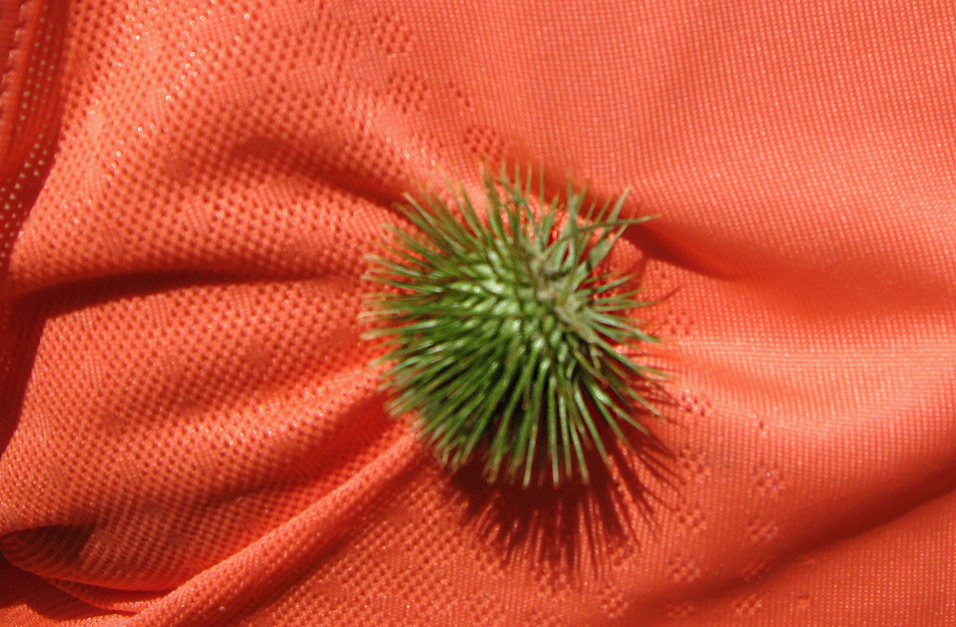
What did he do with the burrs? |  | _
A | He pulled off the burrs and burned them.
B | He planted the burrs near his cabin.
C | He put one of the burrs under a microscope.
D | He put all the burrs into the trash can.

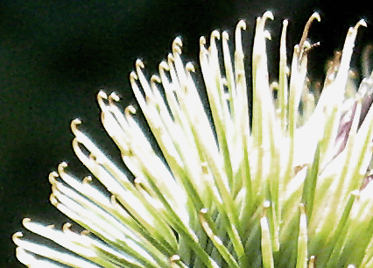
What did George find out when examined a burr up close? |  | _
A | He saw sticky sap on each spine of the burr.
B | He saw very sharp spines on the burr.
C | He saw little hooks on each spine of the burr.
D | He saw tiny insects living on the burr.


When people laughed at George de Mestral’s idea, what did he do? |  | _
A | George did not give up. He continued working on his idea.
B | George got very angry and moved away so people would not laugh at him.
C | George went on a vacation to get away from the people who laughed at him.
D | George became discouraged and gave up his idea.

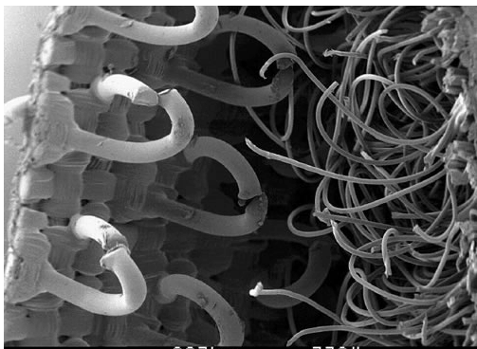
What did George de Mestral invent? |  | _
A | Safety pin
B | Zipper
C | Pizza cutter
D | Velcro®

